Publish Sql database using Azure Portal with ASP.NET CORE Web Api Project

Requirements:

Create azure account with subscription:

Account: [pusamsaikumar302@gmail.com](mailto:pusamsaikumar302@gmail.com)

Password:AmmaNana123

Git-Hub Account:

Name: [pusamsaikumar302@gmail.com](mailto:pusamsaikumar302@gmail.com)

Password:saikumarP123

Go to azure portal:

Create sql database:

Create basic SQL server

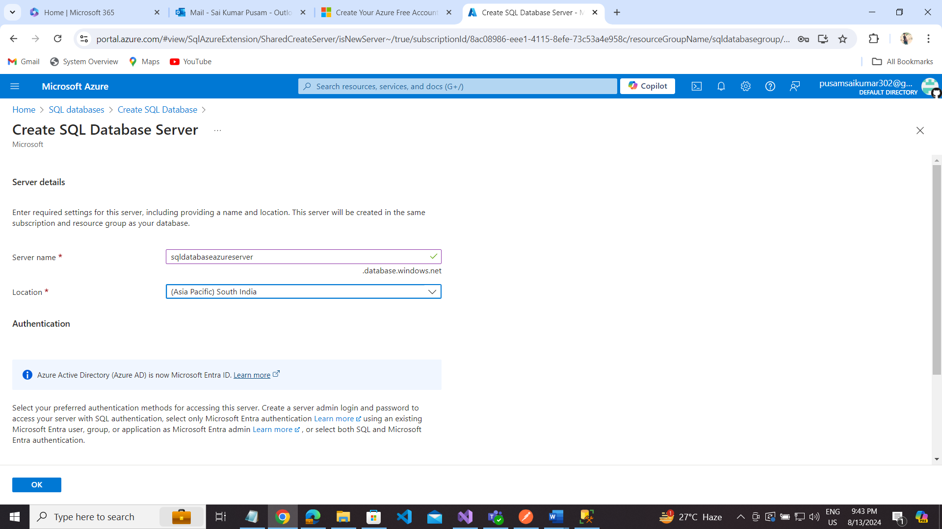

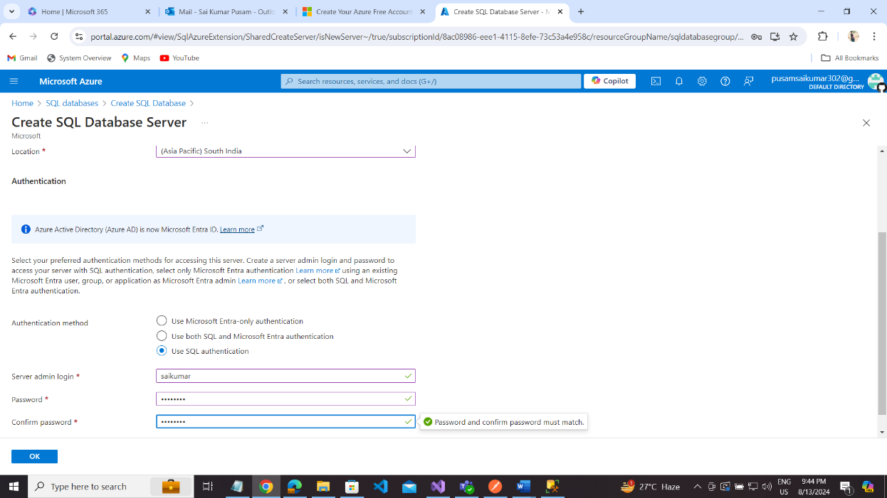

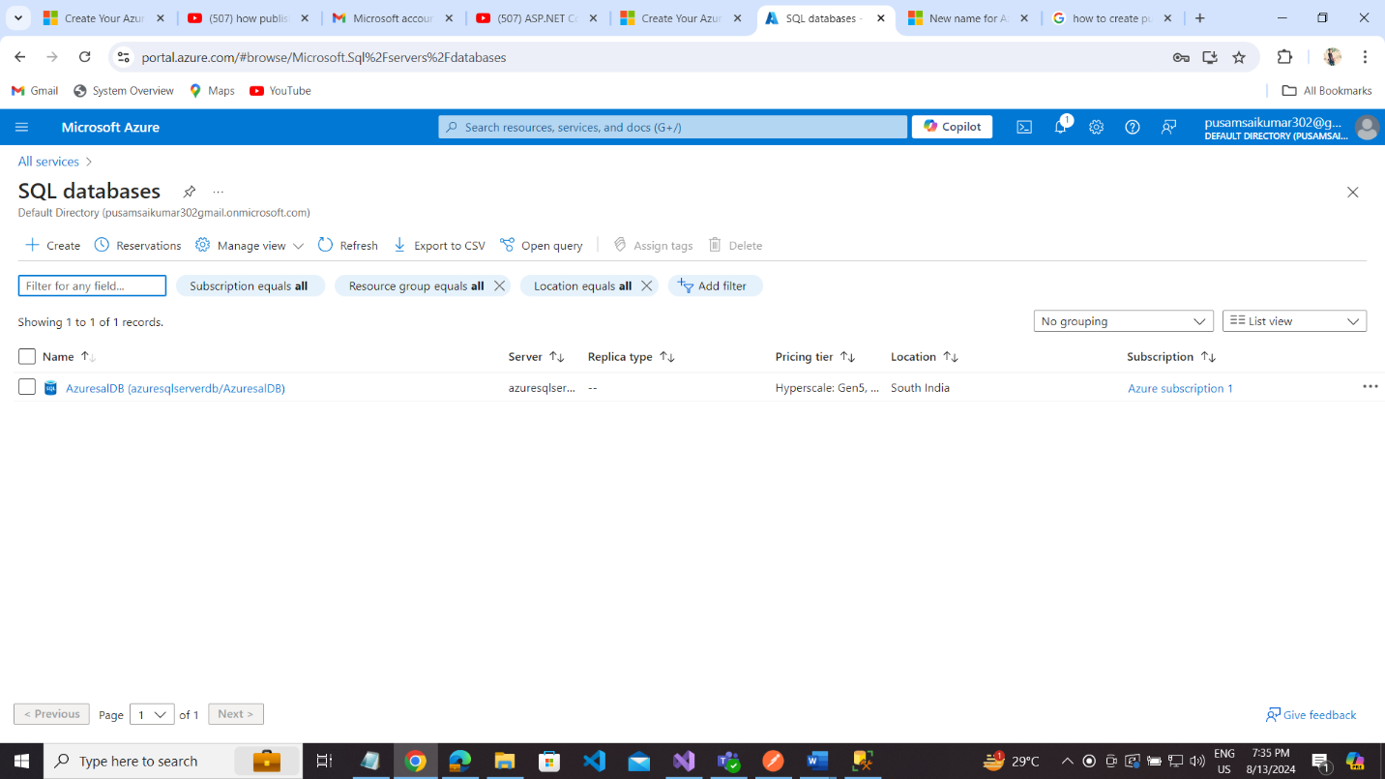

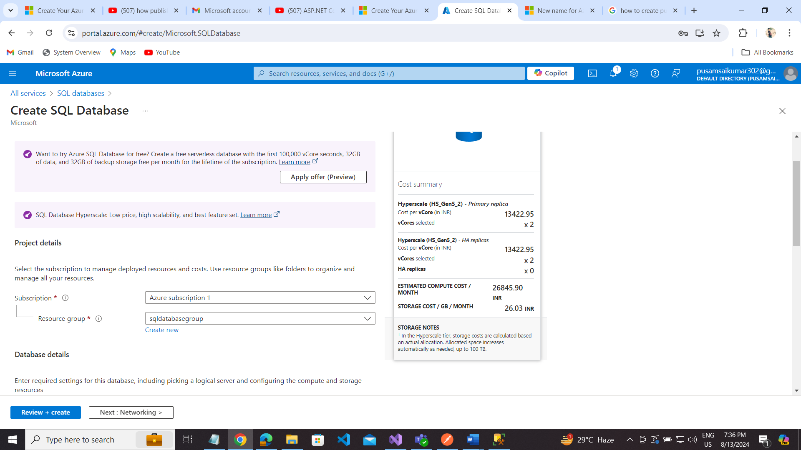

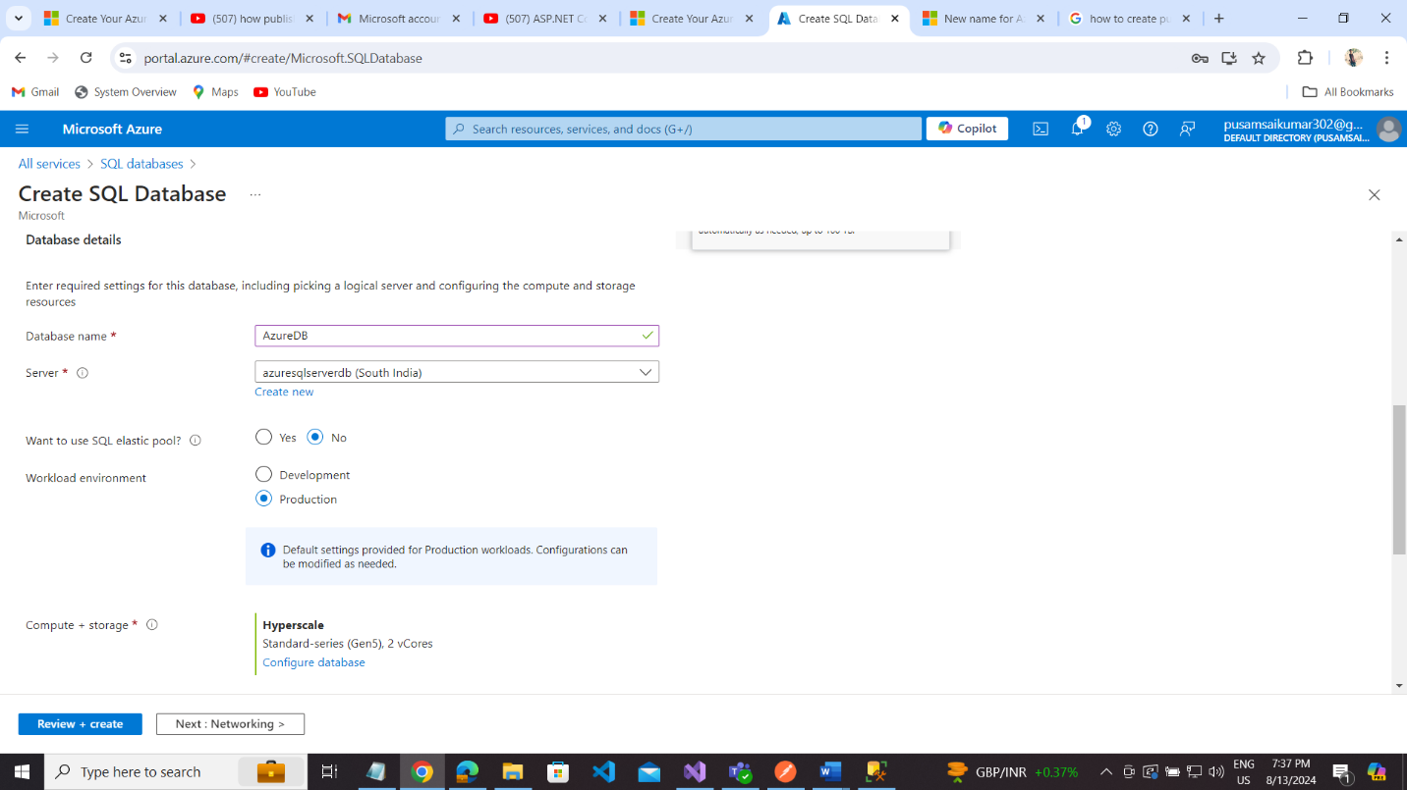

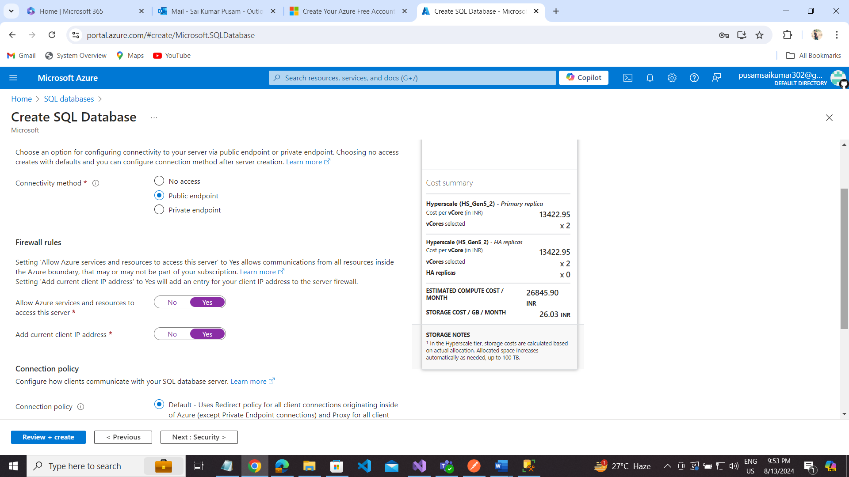

Next: Security

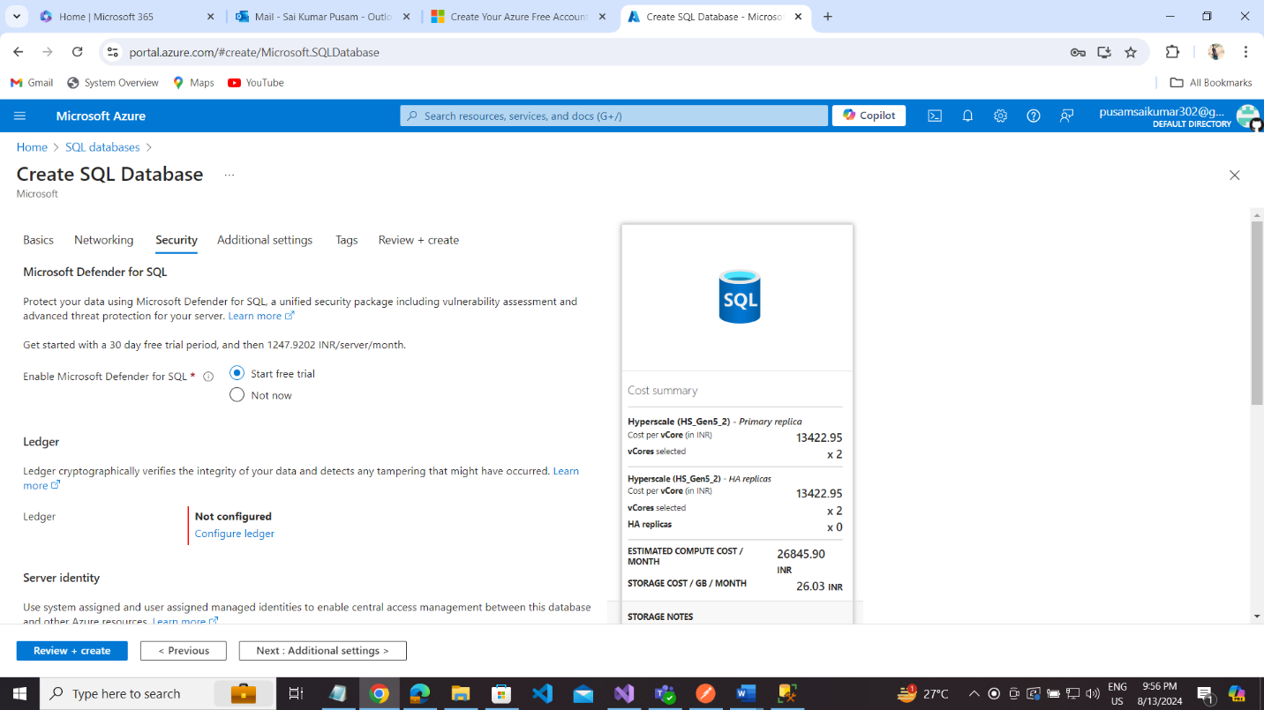

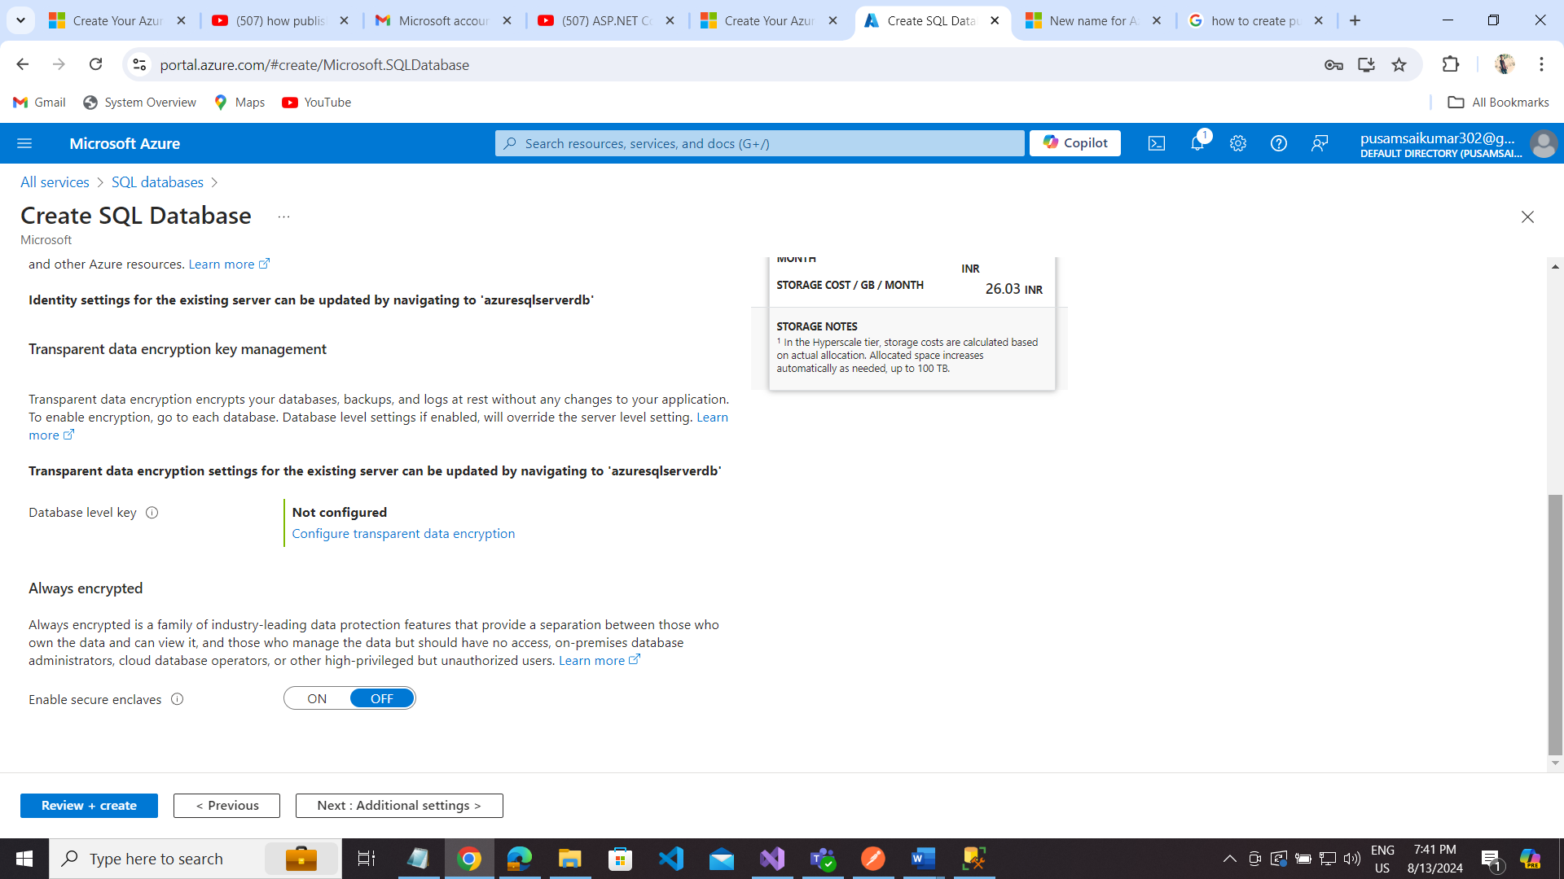

Next: AdditionalSettings

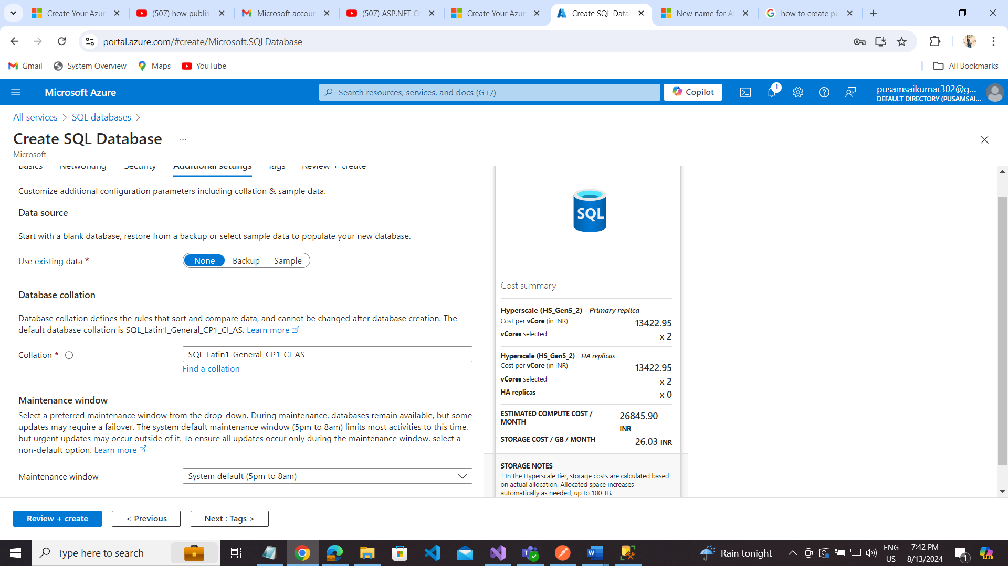

Next: Tags

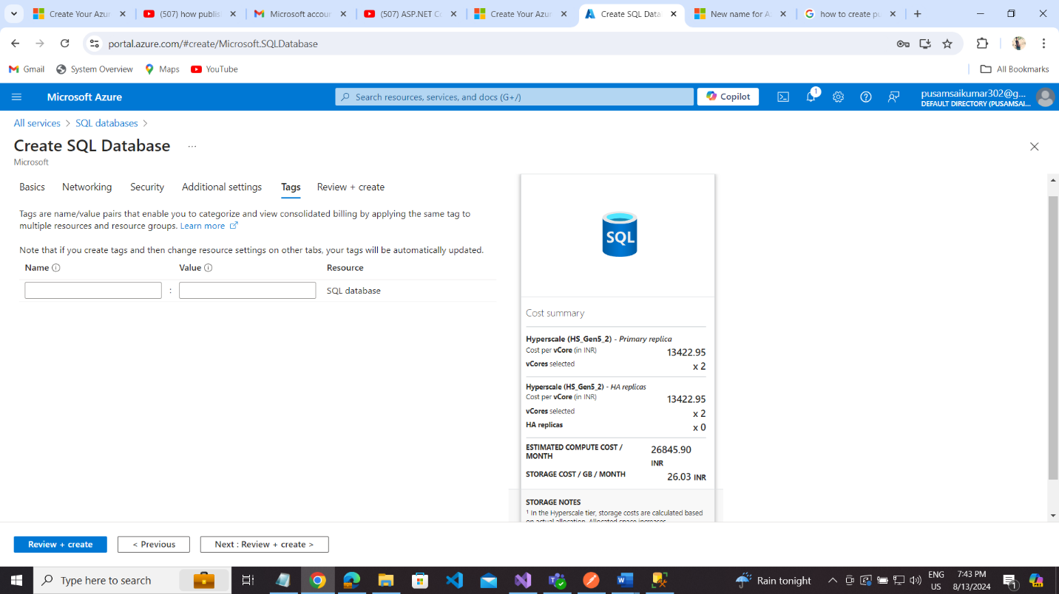

Review create  
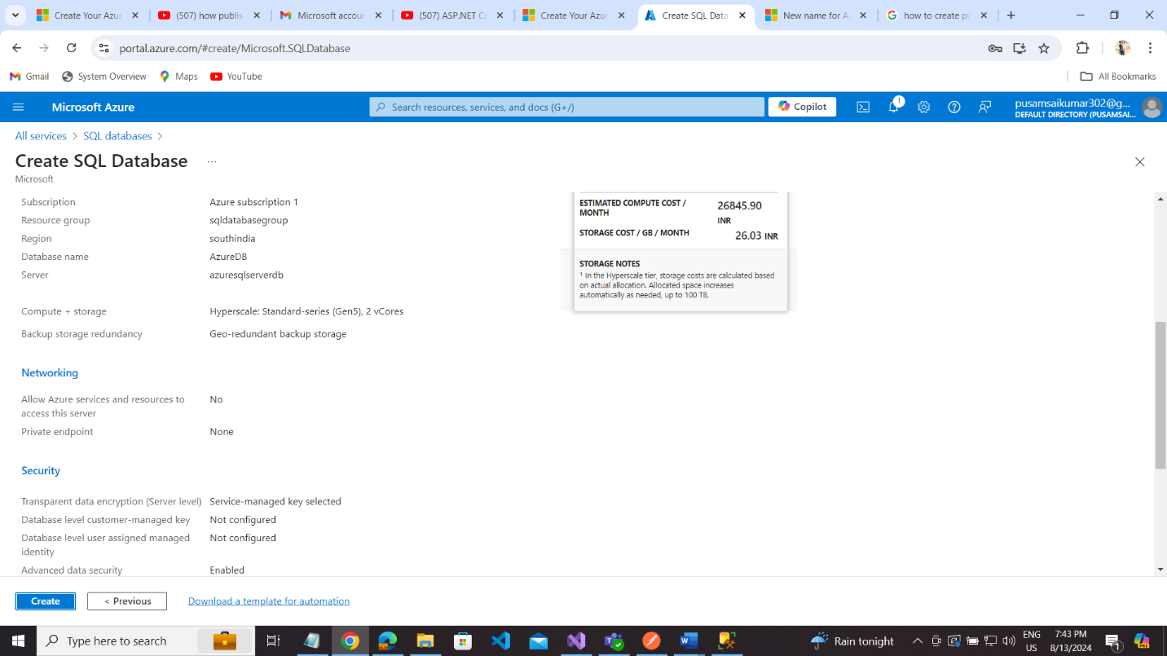

Go to resource:

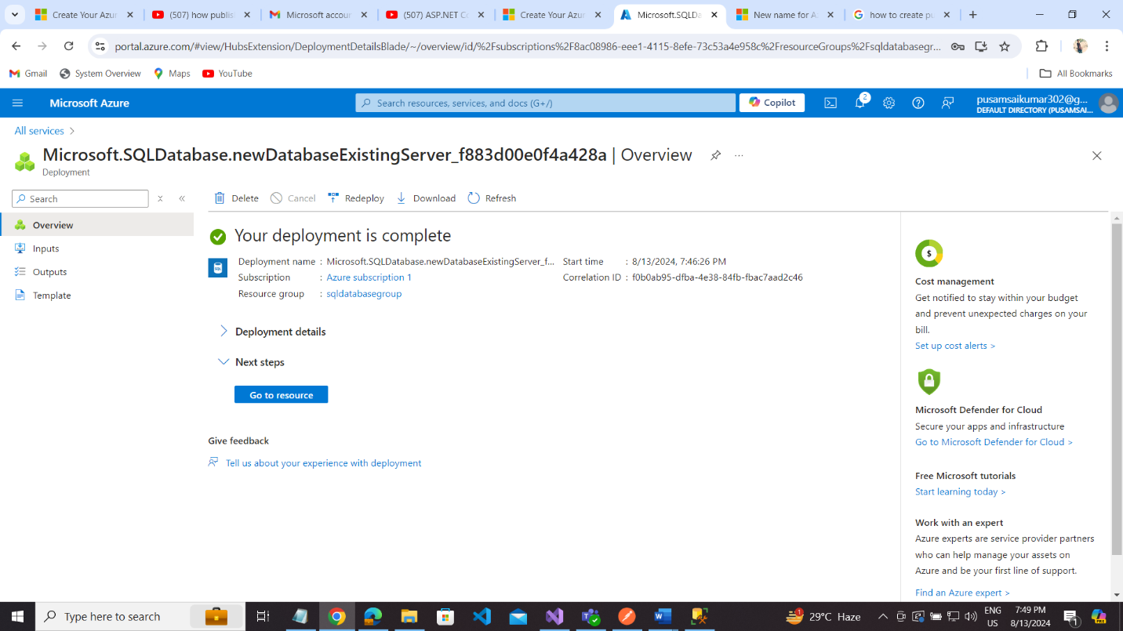

Copy server name here to connect local sql server database

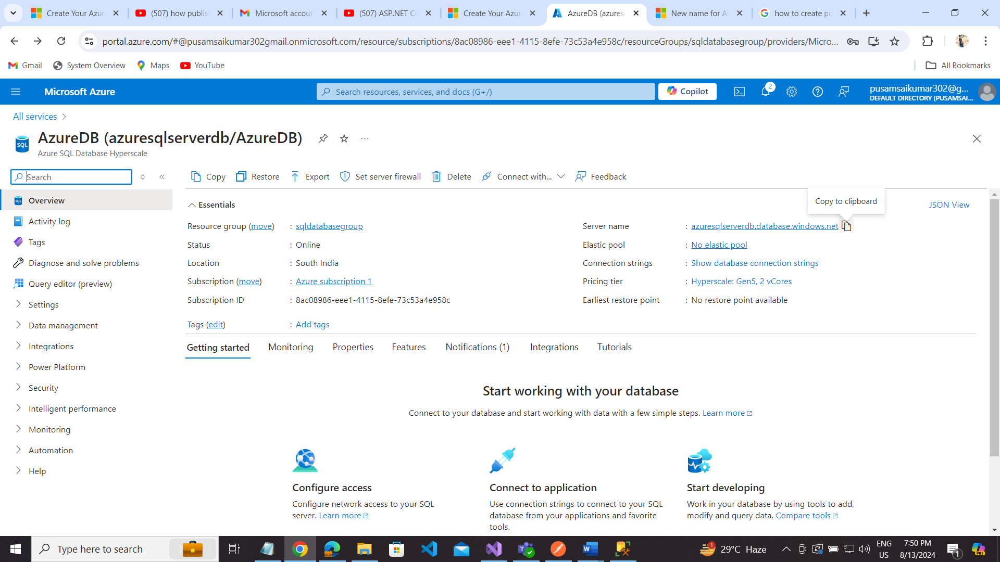

Server Name: azuresqlserverdb.database.windows.net

Authentication: SQL Server Authentication

Login: saikumar

Password: S@1kumar

Database Name: AzureDB

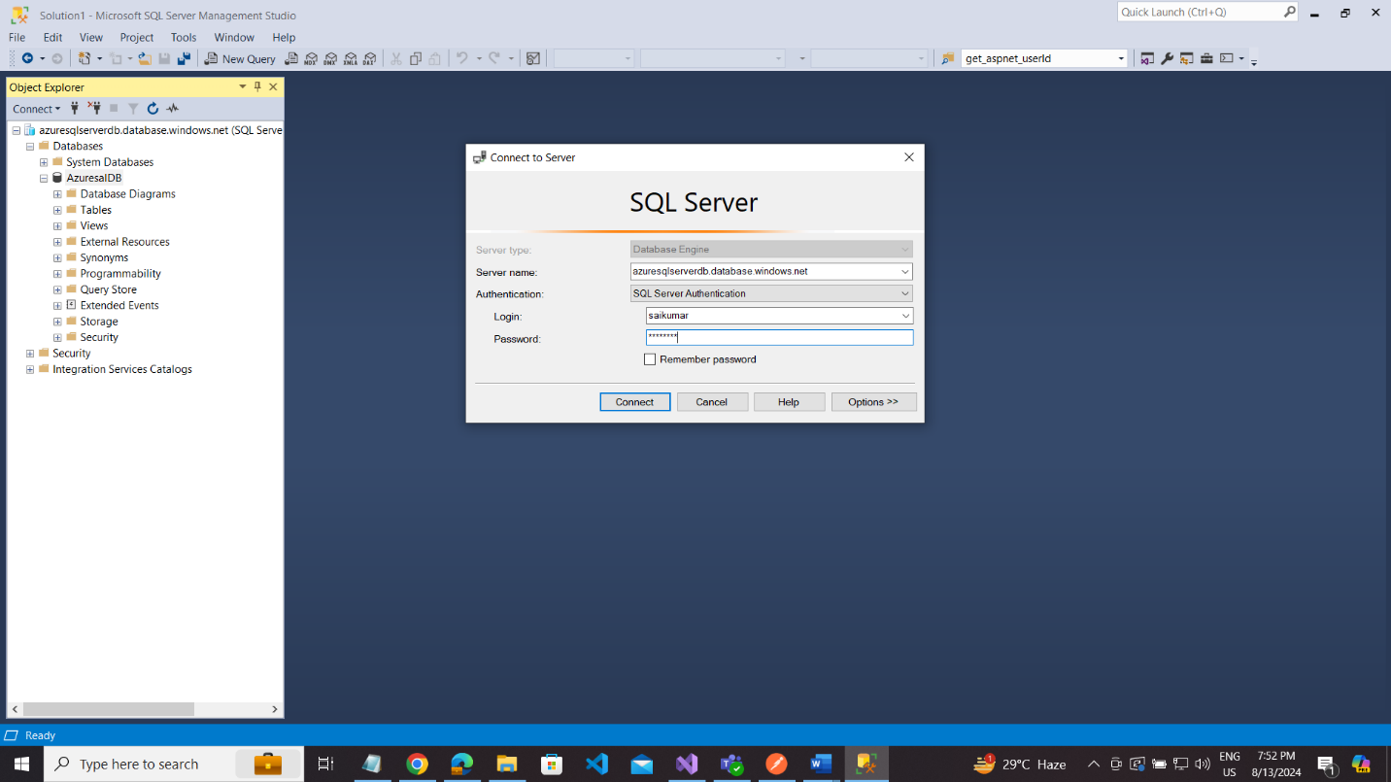

Add connection strings to your project:

"ConnectionStrings": {

// "AuthDBCon": "Server=DESKTOP-1JNARAI\\SAISQLSERVER;Database=AuthenticationDB;User Id=sa;Password=sai123;Integrated Security=False;MultipleActiveResultSets=true;TrustServerCertificate=True;Encrypt=False"

"AuthDBCon": "Data Source=DESKTOP-1JNARAI\\SAISQLSERVER;Initial Catalog=AuthenticationDB;User ID=sa;Password=sai123",

"AzureDBCon": "Data Source=azuresqlserverdb.database.windows.net;Initial Catalog=AzureDB;User ID=saikumar;Password=S@1kumar"

},

Go to asp.net core 8 web api project:

Right click of your project and select publish:  
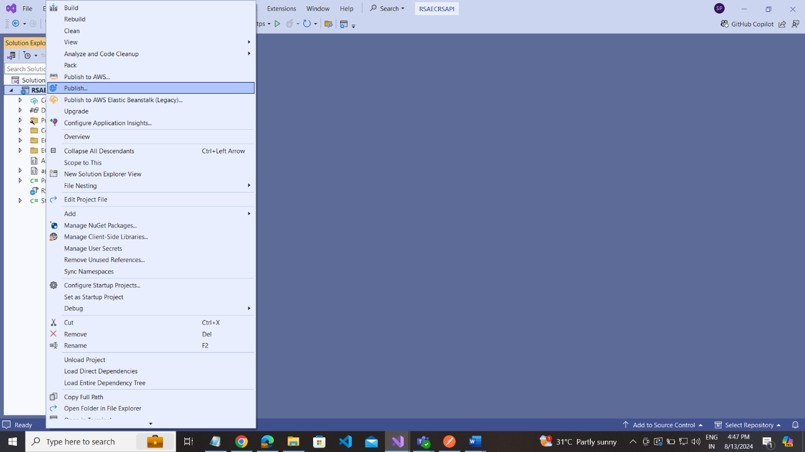

Select Azure

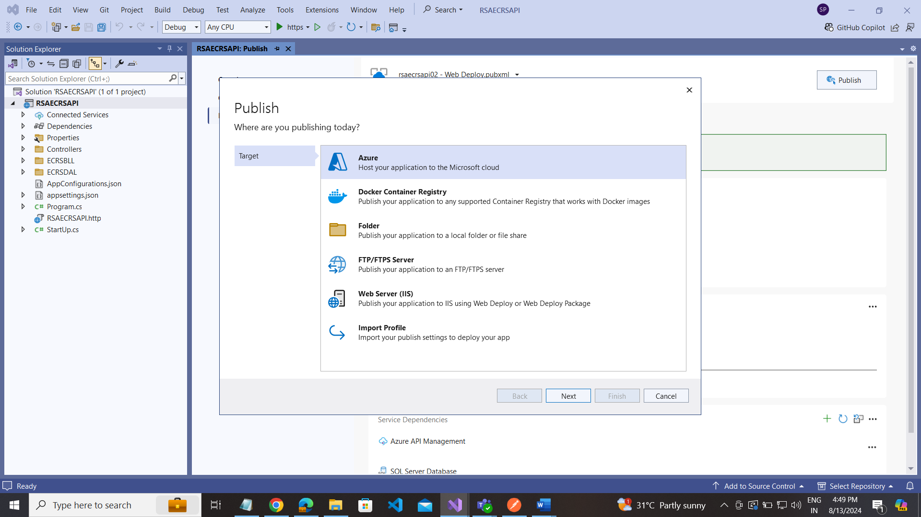

Select Azure App Service(Windows)  
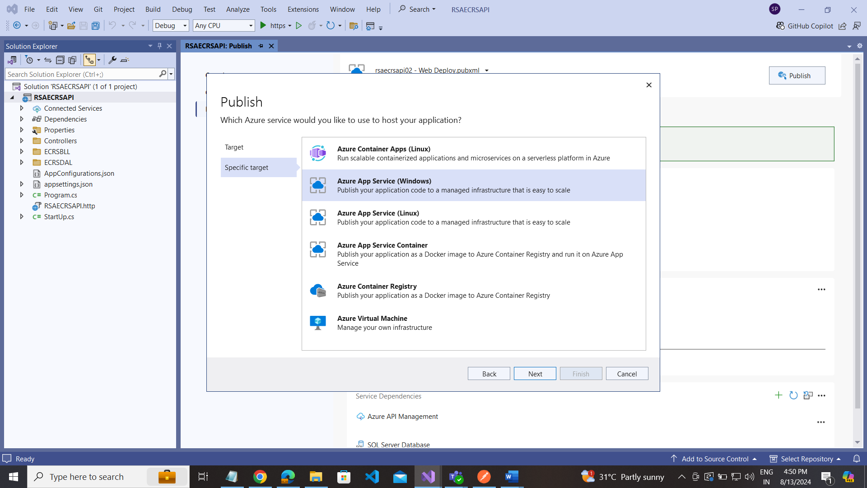

Note: Make your microsoft account matched with your Azure web app service  
In my case im given my microsoft azure account.

Make sure Basic Authentication Enable .

Select ------ Subscription --- App service Name

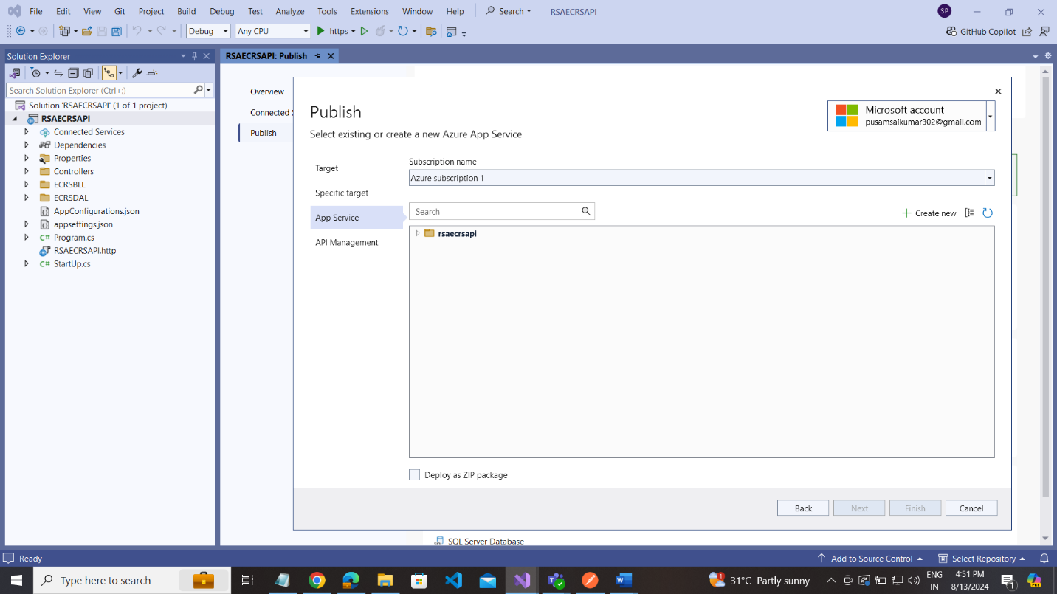

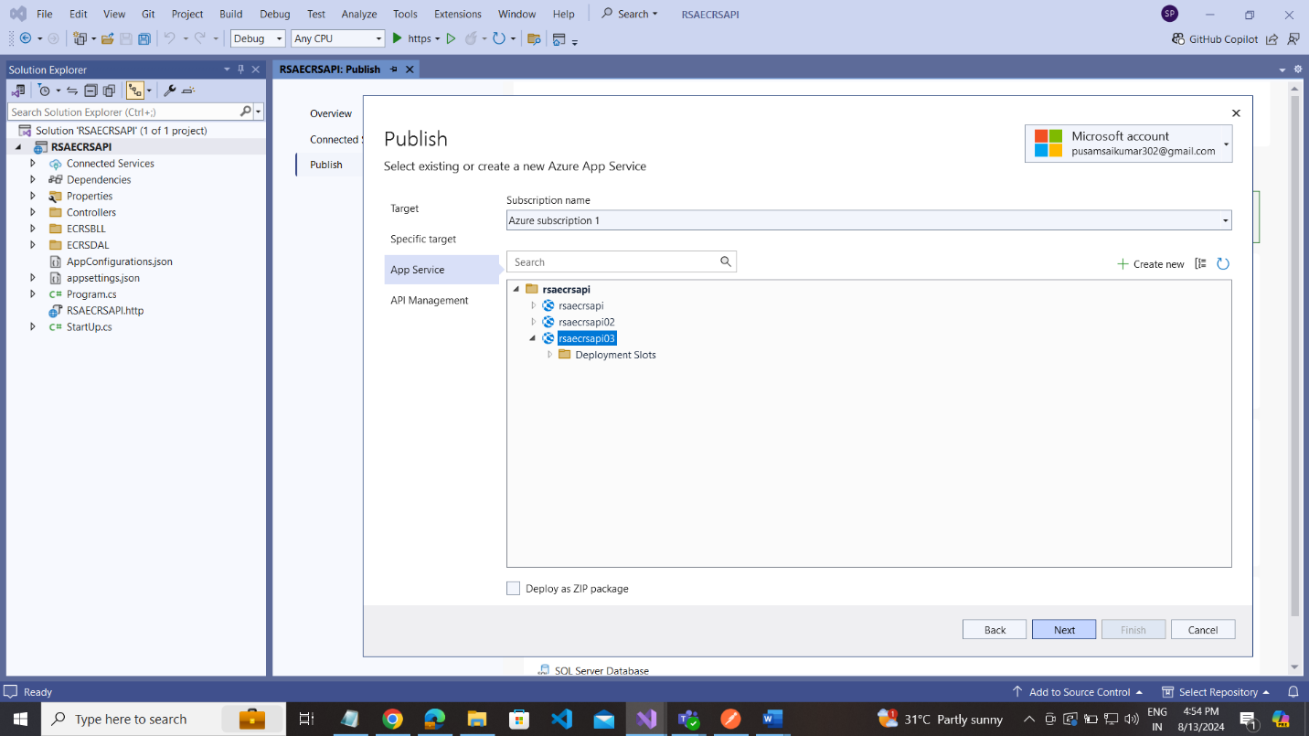

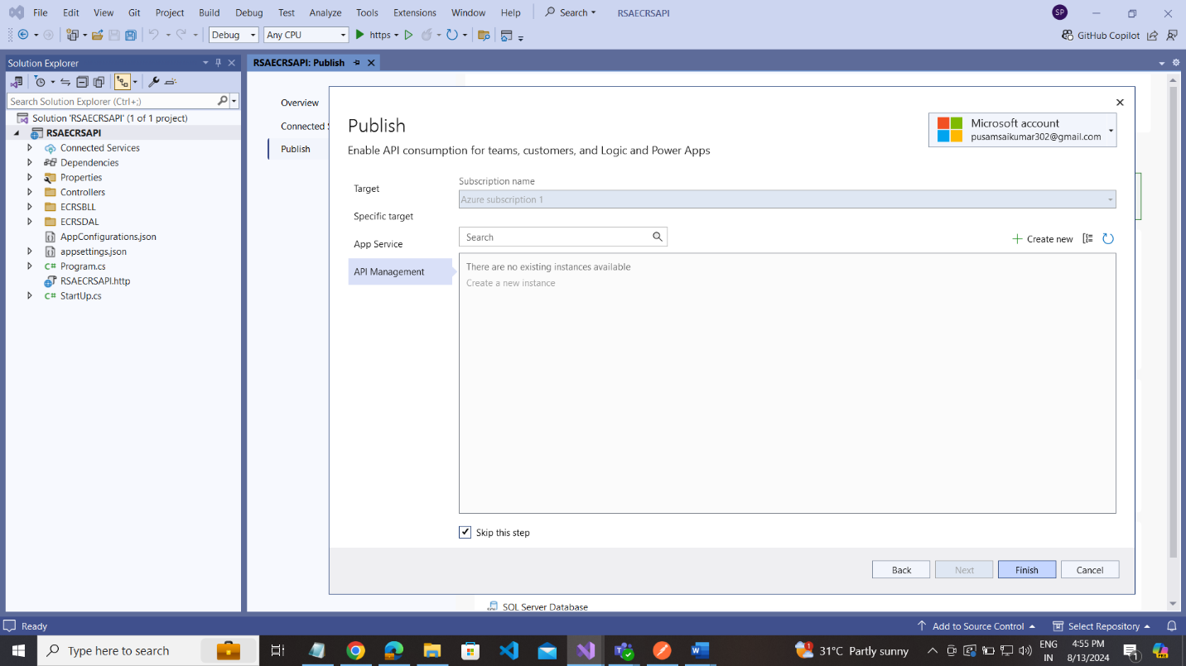

Click on the Publish button.

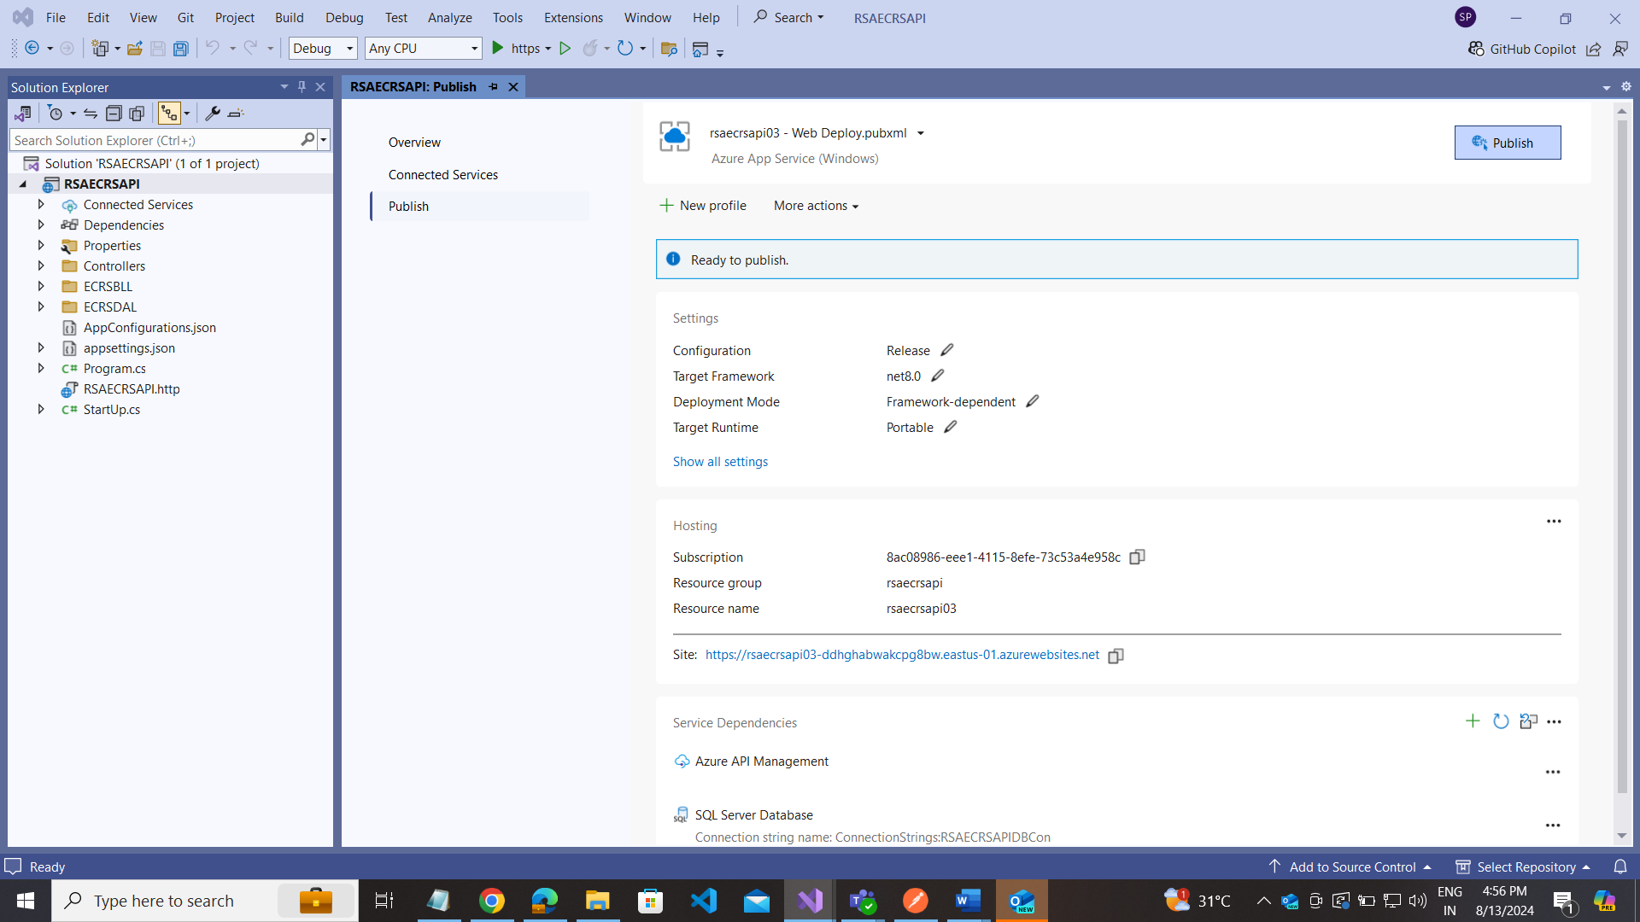

Successfully Published your project:

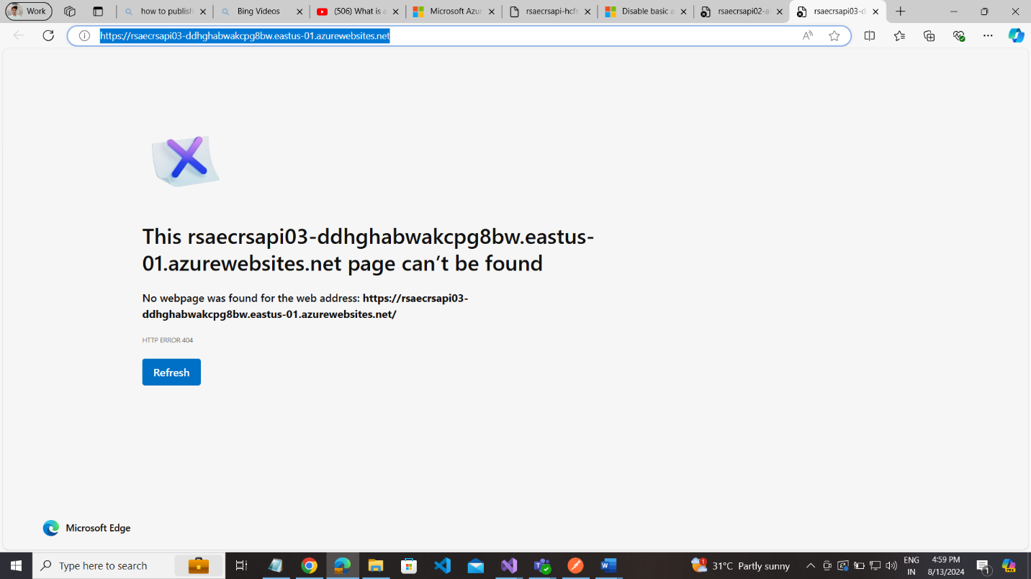

Testing with adding your api endpoints of your project.

url: [rsaecrsapi03-ddhghabwakcpg8bw.eastus-01.azurewebsites.net/api/Customer/GetCustomers](https://rsaecrsapi03-ddhghabwakcpg8bw.eastus-01.azurewebsites.net/api/Customer/GetCustomers)

